Conditional Formatting:

Trade Volume:

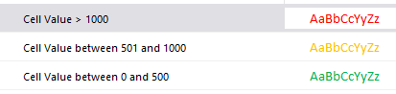

Number of Unallocated Trades:

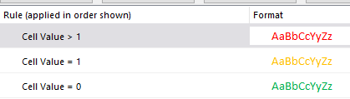

Number of Alleged Trades/Confirmation:

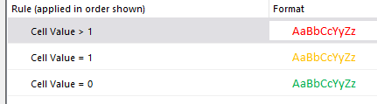

Number of Amendment/Cancellation:

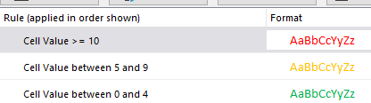

Number of Outstanding Outgoing Trade Confirmation:

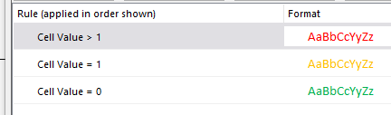

Number of Failed Trades:

For the 2nd to 4th tier, yellow if > 0, else green

Trade, Position, Depot and Nostro Break Aging:

For the 2nd to 4th tier, yellow if > 0, else green

Nostro Overdraft:

